# Front End Challenge

## Overview

The goal of this challenge is to implement a user interface to pick cities from a long list of the major cities in the world. We're looking for an idea of how you handle code organization, user experience, performance, and collaboration in your day-to-day.

A link with a companion ZIP file that includes the API backend is included in the invite to the challenge. Check the zip file README for instructions about running the backend locally, and for a reference of the API endpoints (please consider the API might fail).

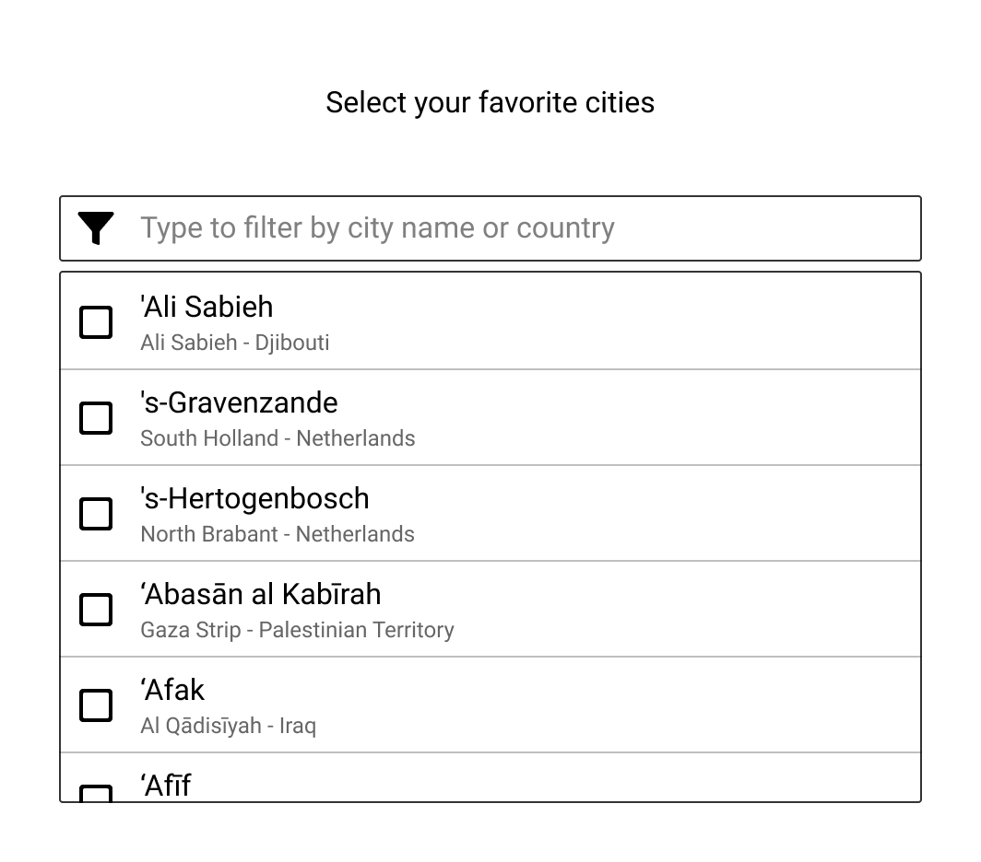

The user selects cities by scrolling the list. The typing in the input field filters the list.

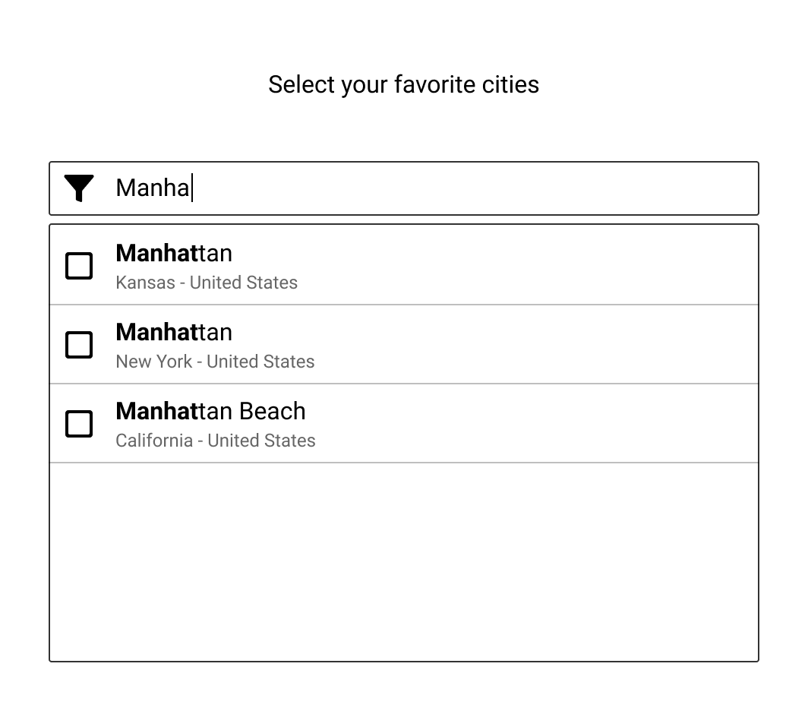

The selection appears as checked items and on top of the input field. Bear in mind that some cities have the same name in different states.

Each time the user selects an item, the UI will save the selection on the server by using the API (see the PATCH method for /preferences/cities).

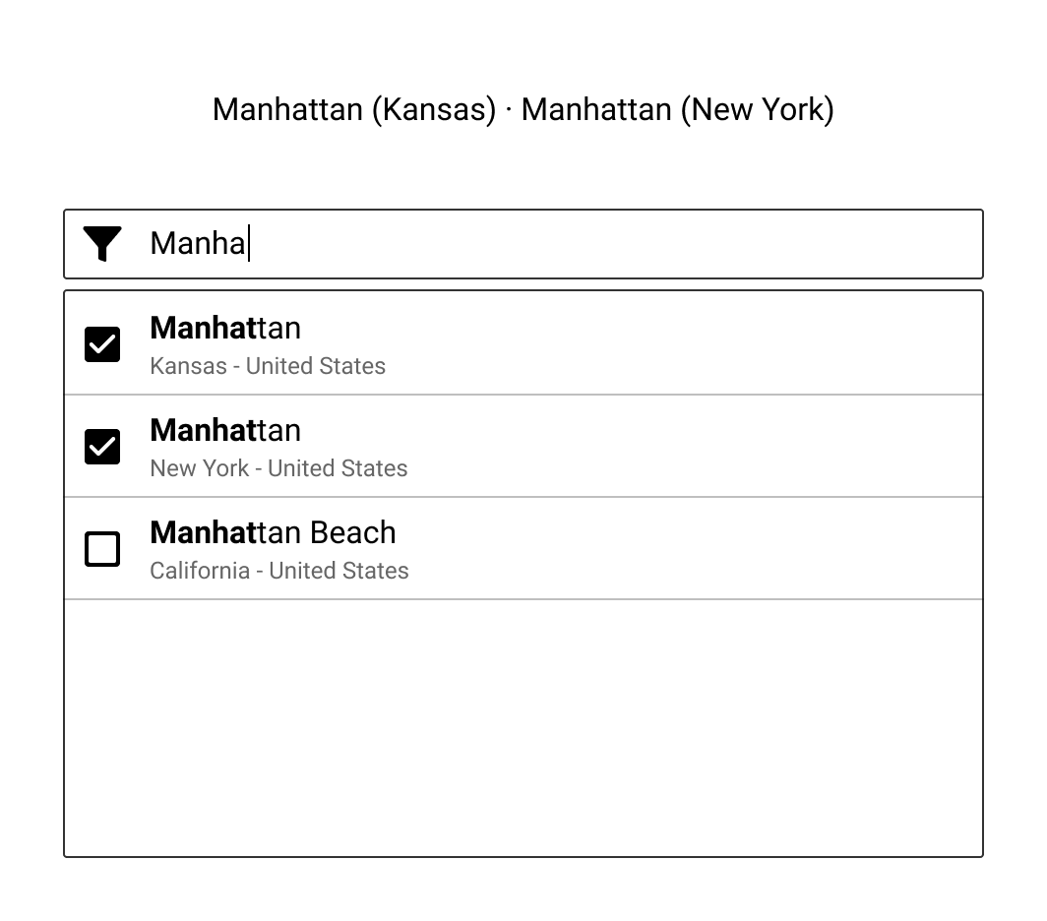

The filtering performs a string match on the city name, country, and area.

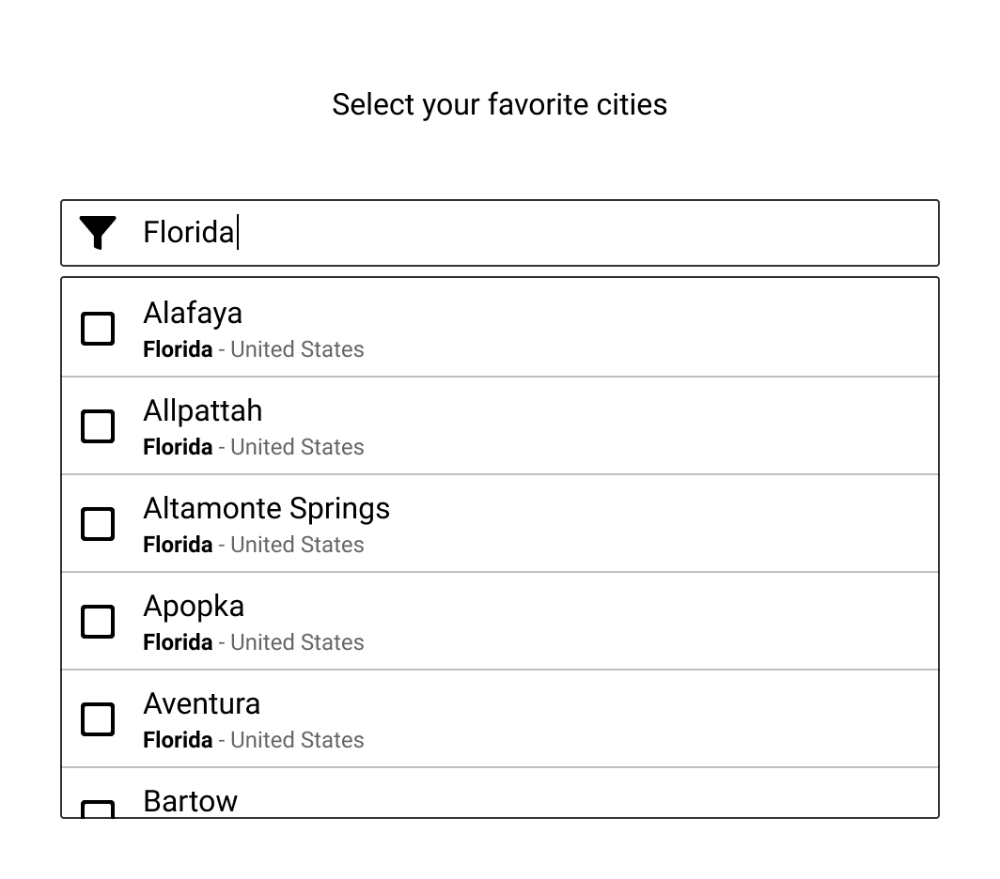

## Styling

The low-fidelity mockup presents an idea of how the UI should look like, it's just an example. Part of the challenge is for you to propose a new design, feel free to apply any visual styling you want.

## UX

The proposed UI has some user experience issues. As an extra, you can explain what are the usability issues, and propose a new design to fix them.

**NOTE: This is optional and not required by the challenge.**

## Challenge Constraints

You are allowed to use:

* Any front-end framework: React, Vue, Angular, Svelte, etc.
* Any state management library or helper.
* Any CSS solution.
* Any icon library like Material Icons, Ionic, etc.
* Any tooling: Webpack, Rollup, TypeScript, Babel, etc.
* UI components like Material UI, Ant Design, etc.   
  However, take into account that the goal is to see how you implement the components to solve this problem. In case of doubt send us an email.

## Deliverables

* Once your challenge is finished you can submit it in a number of ways:
  + A GitHub/GitLab/BitBucket repository link (preferred)
  + A gzip or zip file
  + A Google Drive (or similar) link  
      
    **NOTE:** Avoid squashing your commits if possible and remove the node_modules directory before submitting your response.
* Make sure that the UI can be started with the usual npm install && npm start commands
* If you have ideas to improve the UX, add them to a README in your solution